BIT MANUPULATION

These are computationally very fast as they directly work on bits.

1. Binary representation of a number 🡪
2. 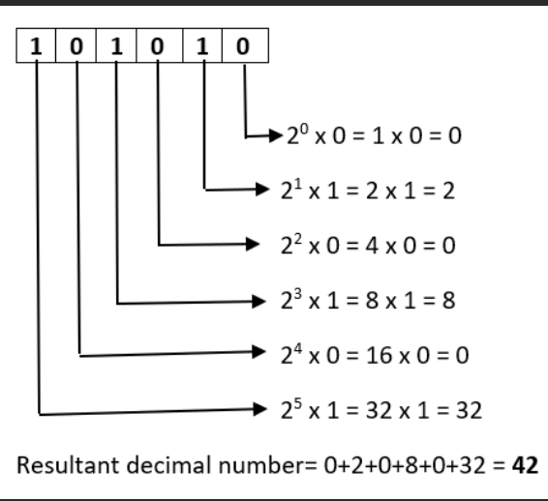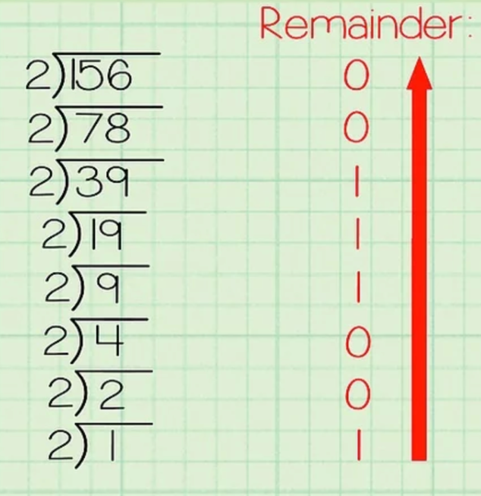We repeatedly divide the number by 2 till it becomes 1 and note the remainder at each stage and the final answer is the reverse of the remainders found.
3. To convert binary to decimal we start with LSB and move towards MSB.
4. 2’S complement 🡪 It is the negative of a number used in case we need to subtract a number we need negative of that so we use two’s complement.
5. Take inverse of all the bits.
6. 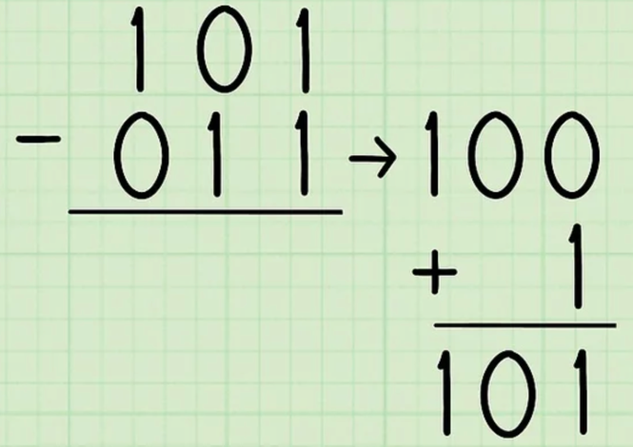Add 1 to the result
7. Bitwise Operators
8. & 🡪
9. | 🡪
10. ! 🡪
11. ^ 🡪
12. ~ 🡪 Inverses all the bits
13. >> 🡪 right shift operator. Eg. 12>>2 shifts bits of 12, 2 times to right
14. << 🡪 left shift operator. Eg. 12<<2 shifts bits of 12, 2 times to left
15. Bit masking🡪 if we want to set a bit or identify a bit at any position. Obtain by AND or OR by any digit.
16. Bit at ith position

Left shift 1 till ith position and do ‘and’ with the given bits.